
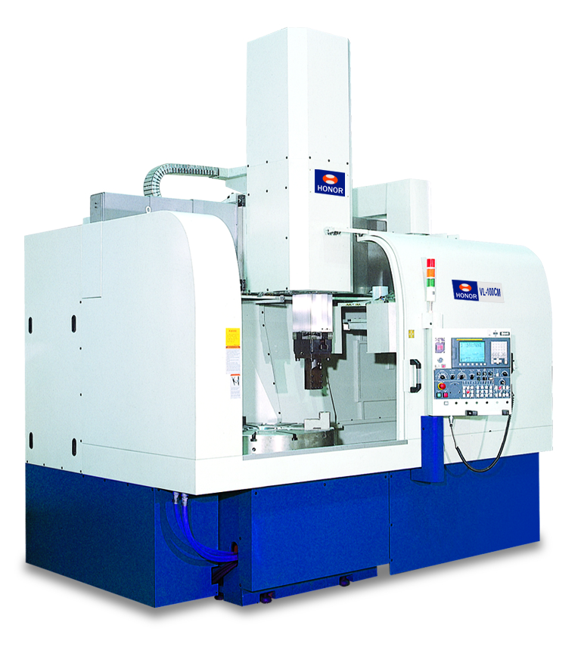

VL-100C / VL-100CM
CNC Vertical Lathes

with Fanuc Control
January 2013

STANDARD FEATURES

MANUAL 4-JAW CHUCK (39.3”) | ELECTRIC TORQUE LIMIT
HEAT EXCHANGER FOR SPINDLE BEARING & GEAR | LEVELING BOLTS & PADS
Complete Splash Guard FULL ENCLOSURE | CHIP CONVEYOR, HINGE TYPE
HYDRAULIC POWER UNIT | CHIP TROLLEY
COOLANT THRU TOOL HOLDER | TOOL HOLDERS
AUTOMATIC LUBRICATION SYSTEM | SPINDLE ORIENTATION
SPINDLE CHILLER FOR GEARBOX AND SPINDLE | ELECTRICAL & HYDRAULIC CIRCUIT DIAGRAM MANUAL
WORK LIGHT | FANUC CONTROL MANUAL
STATUS LIGHT (R/Y/G) | OPERATION & MAINTENANCE MANUAL
WORKPIECE COUNTER | SERVICE TOOL BOX & TOOL KITS
COOLANT SYSTEM WITH TANK | HEAT EXCHANGER FOR ELECTRICAL CABINET
COOLANT BED SHOWER SYSTEM

BASIC MACHINE SPECIFICATIONS

VL-100C FIXED RAIL CAPACITIES
Maximum Swing Diameter 47.26”
Maximum Turning Diameter 47.24”
Maximum Turning Height 25.59”
Vertical Travel (Z-Axis) 23.62”
Cross-section of Ram 7.87” x 7.87”
Horizontal Travel (X-Axis) L -3.93” / R +27.56
Distance from Ram to Table 12.82”- 36.42”
Maximum Work Piece Weight 7,700 lbs.
Cross-Rail Travel Fixed

VL-100C PROGRAMMABLE RAIL CAPACITIES (Optional)
Maximum Swing Diameter 47.26”
Maximum Turning Diameter 47.24”
Maximum Turning Height 37.4”
Vertical Travel (Z-Axis) 27.56”
Horizontal Travel (X-Axis) L -3.93” / R +27.56
Distance from Ram to Table 19.7”- 43.31”
Maximum Work Piece Weight 7,700 lbs.
Cross-Rail Travel (Programmable by M-code in Auto) 23.6” (3 X 7.87” Steps)

* Machines fitted with the optional power chuck adapter, please subtract 2.9” from “Maximum Turning Height”

* Honor Seiki’s moveable rail is programmable by M-code, this allows for a continuous turning operation
as the rail is moved and re-positioned in the memory mode.

SPINDLE
Spindle RPM 3-400 RPM
Table Diameter 39.3
2 Speed Heavy Duty Gear box 2-Step s
Spindle Torque 10,700 ft-lbs.
Spindle Bearing Diameter 18”
Spindle Bearing Manufacturer Timken/PSL/THK
Height of Spindle Face from Floor 39.3”

ATC SYSTEM – VL100C
Number of Tools 12
Tool Size 32mm / 1.25”
Cross-section of Ram 7.87” x 7.87”(200 x 200mm)

ATC SYSTEM – VL100CM (With Milling Capabilities)
Number of Tools 12 (16 Optional)
Live Tool Spindle Speed (VL-100CM) 50-2250
Spindle HP 20 HP
Tool Size 32mm / 1.25”
Cross-section of Ram 8.66” x 8.66” (220 x 220mm)
C-Axis 0.001”
*Standard Supplied Tool holders for the C and CM are listed under Tooling Options

FEEDS
Rapid Traverse Rate X, Z 393 IPM
Horizontal Travel (X-Axis) -3.93” / +27.56
Vertical Travel (Z-Axis) 23.62”
X-Axis Axial Thrust 2,684 lbs.
Z-Axis Axial Thrust 2,684 lbs.
Positioning Accuracy ± .0003” (Full Stroke)
Repeatability ± .0002”
*
All accuracies stated are (JIS Standard) and are guaranteed only if the machine is installed in a temperature controlled environment along with the proper foundation meeting the minimum requirements of the machine tool builder. Please Contact CNC Systems for the specific machine requirements.

MOTORS
Spindle Motor Power AC 50HP (60HP Option)
Feed Motor (X/Z Axis) AC 6 HP
Live Tool Motor (VL-100CM only) AC 20HP

COOLING SYSTEM
Pump 1 – Bed Washing 3 Bar
Pump 2 – Coolant Thru Spindle 3 Bar C Type
10 Bar M Type

GENERAL
Net Weight (VL-100C / VL-100CM) 34,100 lbs. / 36,000 lbs.
Floor Space (LxW) 159.45” x 114.17”
Maximum Height 157.74”
Power Requirement (VL-100C / VL-100CM) 75 KVA / 90 KVA
Coolant Tank Capacity 400 liters

FANUC Oi-T CONTROL FEATURES

- 400 Registerable Programs
- 8.4” Color High Resolution LCD
- Absolute/Incremental Command
- Additional Macro Common Variables 100-199
- Auto Acceleration/Deceleration
- Auxiliary Function Lock
- Background Editing
- Backlash Compensation
- Canned Cycles for Drilling
- Canned Cycles G90-G92-G94
- Constant Surface Speed Control
- Controlled Axis: 2
- Custom Macro B
- Data Protect Key
- Decimal Point Input
- Dry Run
- Dwell (G04)
- Fanuc Alpha I AC Digital Servo and Spindle Systems with 1,000,000 Pulse Encoders
- Feedrate Override 50~150%
- Full MDI Keyboard
- Graphics Function (3D)
- Inch/Metric Conversion
- Incremental Feed (X1, X10, X100, X1000)
- Machine Lock (All Axis)
- Manual Feedrate Override (0-150%)
- Multiple Repetitive Canned Cycles (G70-G76)
- Optional Block Skip
- Polar Coordinates
- Program Input/Output or DNC Operation from PCMCIA Card on Front Panel (Up to 2GB Storage)
- Program Memory 640 Meters (265K)
- Program Stop/Program End (M00, M01, M02, M03)
- Programmable Input (G10)
- Rapid Traverse Override (0-100%)
- Reference Point Return (G27, G28)
- RS232 (reader/puncher interface)
- Run Hour and Parts Count Display
- Second Reference Point Return
- Single Block
- Skip Signal and High Speed Skip Signal
- Spindle Orientation M-19 (1 position)
- Spindle Speed Override (50~120%)
- Stored Pitch Error Compensation
- Stored Stroke Check 1
- Tool Geometry/Wear Offsets 64 Pairs
- Tool Length Compensation (G43, G44, G49)
- Tool Nose Radius Compensation (G40-G42)
- X Axis Radius/Diameter Programming

MACHINE PRICES

Honor VL-100C with Fanuc 0i-T Control, list $POR
Honor VL-100CM with Fanuc 0i-T Control, list $POR

TOOLING OPTIONS

Tooling for VL-100C
Tool holder Base GC-200 (6 are included with machine) $1,550
OD/Face tool holder IDF-1.25-200-200 (2 are included with machine) $1,500
Boring Tool Holder IFL-1.0-120-250 (2 are included with machine) $1,500
Drilling Boring Holder BOS-2.5-140-200 (2 are included with machine) (2.5” – 3.0” Opt.) $1,250

Tooling For VL-100CM
Tool holder base BT-50-200 (6 are included with machine) $2,100
OD/Face tool holder IDF-1.25-200-200 (2 are included with machine) $1,500
Boring Tool Holder IFL-1.0-120-250 (2 are included with machine) $1,500
Boring Tool holder BOS-2.5-140-200 (2 are included with machine) (2.5” – 3.0” Opt.) $1,250
BT-50 Pull studs, each $25.00
Other Tool Holder & Special Tool Holder POR

MACHINE OPTIONS

Hydraulic Chuck & Cylinder, size selections POR
Hard Jaws of Hydraulic Chuck POR
High & Low Pressure Chucking POR
Programmable Rail (3) Steps of 7.87 inches….……………………………………………….…….…$43,000
Power Chuck Adapter (factory installation) $12,200
60HP Spindle Motor up grade $21,500
Air Conditioner for Electrical Cabinet $3,500
Power Transformer, external $7,900
Oil Skimmer (disk type) $2,700
Tool Pre-setter Inside (turning dia. is smaller than spec.) $15,000
Linear Scale X Axis $10,500
Linear Scale Z Axis $6,500
ZF Gear Box for Live Tool Spindle $19,500
Chip Conveyor, scraper type $5,000
Manual Guide $4,900
Lubrication Chiller for Main Spindle Bearing and Gear $6,500.00

